Step1 : created ‘master’ branch and inside that created one file named with ‘file1’

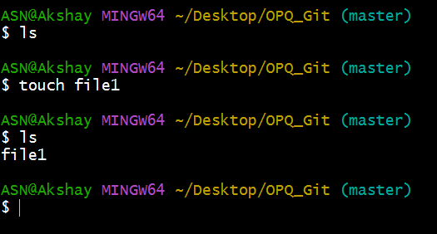

Step2: created second branch called ‘feature1’ from branch ‘master’

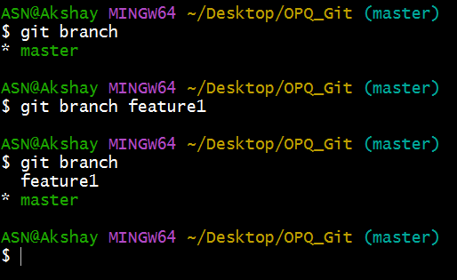

Step3: switched to ‘feature1’ branch to edit the file

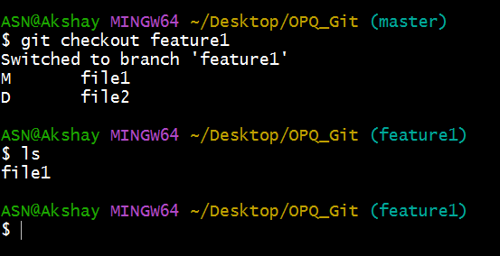

Step4: ‘file1’ edited with ‘hi good morning’ comment switched to ‘master’ branch and edited the ‘file1’ with ‘hello’

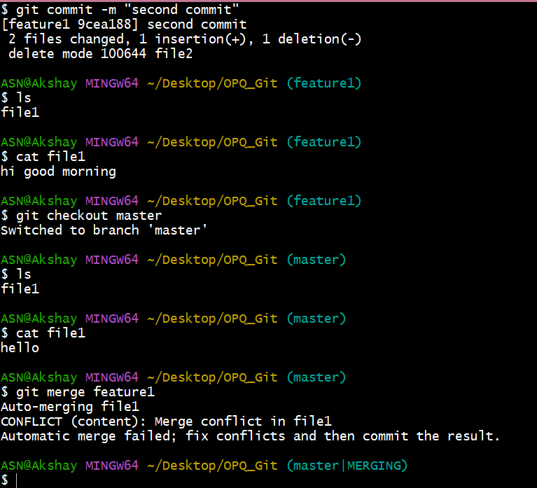

Step5: file is ‘added’ and ‘commited’ to local central repo

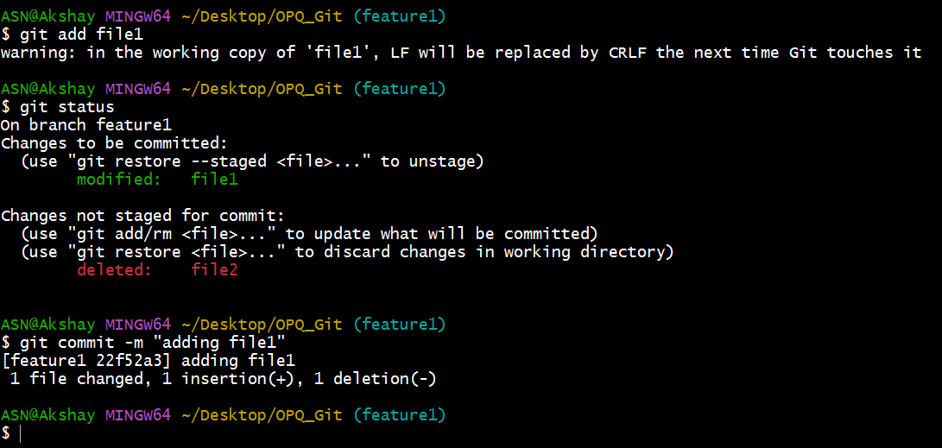

Step6: switched to ‘master’ branch and file is ‘added’ and ‘commited’ to local central repo

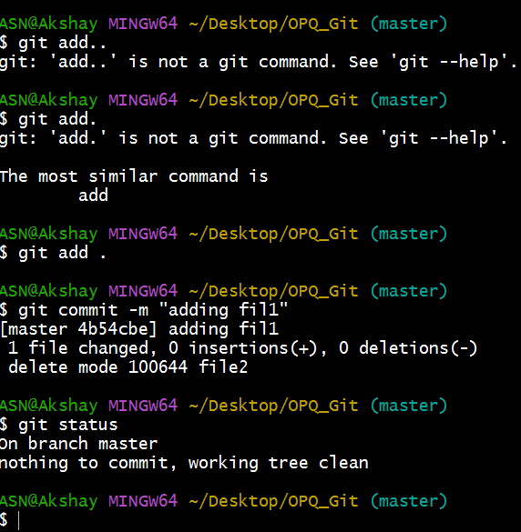

Step7: git merge feature1

Merging Failed

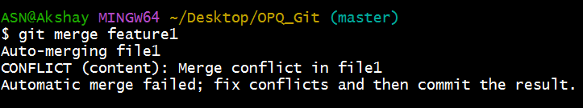

Step8: Open the conflicted files in a text editor

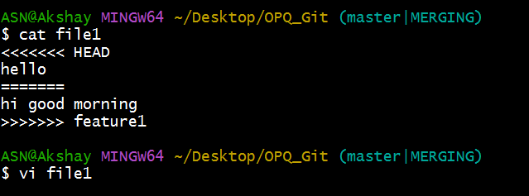

Step9: Edit the file to keep the desired changes. Remove the conflict markers (<<<<<<<, =======, >>>>>>>).

Step10: keep required lines are both lines.

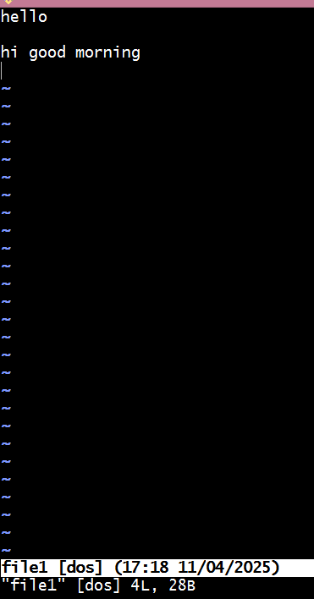

Step11: After fixing conflicts, stage the resolved files. By adding and commit

